MOD 26

Challenge Overview
Category: Cryptography
Difficulty: Beginner
Provided Context: "Cryptography can be easy, do you know what ROT13 is?" followed by a ciphertext that looks something like
cvpbPGS{arkg_gvzr_V'yy_gel_2_ebhaqf_bs_ebg13_45559noq}

The Concept: Modulo 26 & ROT13
The challenge name "Mod 26" is a direct hint to modulo arithmetic based on the 26 letters of the English alphabet.
Looking at the ciphertext cvpbPGS{arkg_gvzr_V'yy_gel_2_ebhaqf_bs_ebg13_45559noq},
you can see it perfectly mirrors the standard PicoCTF flag format
picoCTF{next_time_I'll_try_2_rounds_of_rot13_45559abd}This means c maps to p, v maps to i, p maps to c, and so on.
What is ROT13?
ROT13 (Rotate by 13 places) is a classic substitution cipher that replaces a letter with the 13th letter after it in the alphabet. Because there are exactly 26 letters in the English alphabet, applying ROT13 twice returns the original text.

The Solution
To solve this challenge, you simply need to reverse the ROT13 cipher. Because shifting by 13 twice brings you back to the start, "encrypting" and "decrypting" use the exact same process.
You can solve this using whichever method you find most convenient:
Method 1: Using CyberChef (The Visual Way)
- Navigate to rot13 (an open-source web app for decoding and analyzing data).
- Paste your specific ciphertext into the "Input" box.
- The decoded flag (starting with picoCTF{) will instantly appear in the "Output" box.

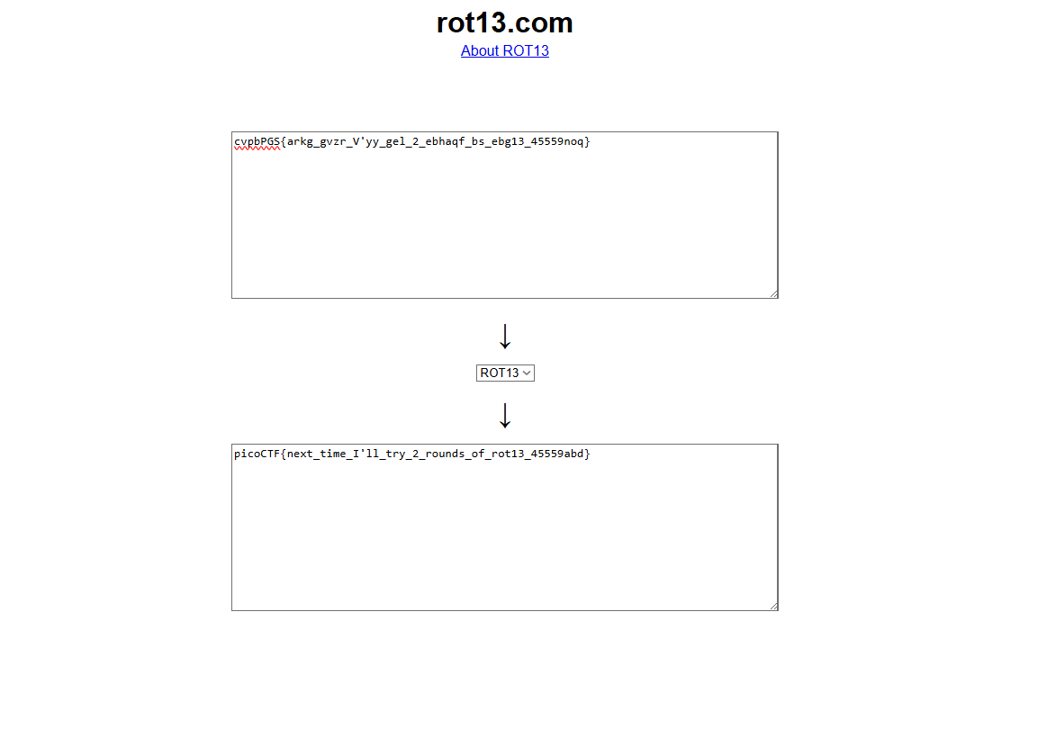Flag: picoCTF{next_time_I'll_try_2_rounds_of_rot13_45559abd}

